Offshore Rigs. Types of Offshore Rigs Used in Modern Oil Drilling.

Annotation. This article is devoted to the development and operation of various types of drilling rigs in the Russian and Global industry.
Keywords: offshore rigs, types of drilling rigs.

Offshore drilling is a mechanical process where a wellbore is drilled below the seabed. It is typically carried out in order to explore for and subsequently extract petroleum, which lies in rock formations beneath the seabed. Most commonly, the term is used to describe drilling activities on the continental shelf, though the term can also be applied to drilling in lakes, inshore waters and inland seas.
Offshore drilling has come a long way since the wharf-based rigs of the late 1800s, giving oil companies an arsenal of options for tapping deep-sea deposits. The world’s first offshore oil rig was built in 1869, the same year the designer T.F. Rowland patented his offshore rig design. Rowland’s concept resembles modern offshore drills, but his designs were used only in shallow waters.
The earliest offshore drilling was limited to coastal oil deposits that were accessible from piers, but oil companies today can choose from a variety of elaborate methods, letting them drill almost anywhere at almost any depth. From roving, computer-controlled contraptions to giant "spar" platforms held up by 10,000-foot poles, today's deepwater rigs are going far beyond anything their offshore forefathers could have imagined. Offshore oil and gas production is more challenging than land-based installations due to the remote and harsher environment. Also for offshore drilling, it is essential to create a platform for maximum drill mining, at the same time ensuring the safety of workers by compensation water of natural movement. A lot of innovations in the offshore petroleum sector concern overcoming these challenges, including the need to provide very large production facilities. Production and drilling facilities may be very large and have got a large investment.
In worldwide offshore drilling industry the requirement of the types of offshore oil drilling rigs are depend on the nature of the drilling operations. The specific offshore drilling rig is designed to function in the specific location with the specific weather condition. Some rigs are stationary and constructed to carry out the drilling operation for a long period in a particular position, where drill ships can move here and there in ocean and can conduct drilling operations in deep-water location. Offshore oil wells are sometimes the only crude oil production that a country has. Improved technology has made it possible to extract oil from deep water. This is welcome news when considering that shallow water reserves are slowly being depleted. However, oil-drilling technology is constantly improved and some rigs combine elements from different models to achieve specific abilities.
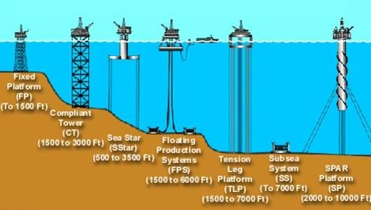
Advances in drilling and production technology have increased the possibility that offshore platforms can be controlled from an onshore location including a function to control the automatic shutoff that will minimize pollution. Offshore oil production involves environmental risks, most notably oil spills from oil tankers or pipelines transporting oil from the platform to onshore facilities, and from leaks and accidents on the platform. Produced water is also generated and brought to the surface along with the oil and gas; it is usually highly saline and may include dissolved or unseparated hydrocarbons.
Types of offshore rigs
Based on operation we can find four primary rig types – Jack-ups, semi submersibles, drill-ships and fixed platforms made up the majority of the offshore rig fleet and all of them are used worldwide.

Сlassification of offshore rigs.
Types of rigs | Production capacity | Application area | Features
Jack-up rig: | 500 000 cubic meters | used for smaller, shallower offshore oil deposits that don't warrant a permanent platform, or for drilling exploratory wells | The rig's floating platform is towed into position by barges, then lowers its support legs down to the sea floor, raising the rig above the water's surface. The platform can then be adjusted to varying heights along its tall legs, essentially using the same principle employed by a tire jack.
Semi-Submersibles | 128 million cubic meters of gas;  110,000 barrels of oil | used for drilling oil deposits in very deep water; typically used in water with a depth of 500 meters or more. | a type of mobile offshore drilling unit;  made up of ballasted columns, watertight pontoons and a system of mooring lines to anchor the rig to the ocean floor;  rely on a dynamic positioning system with computer-controlled propellers and thrusters to stay in place.
Drill-ships | 150 000 barrels of oil;  38 million cubic meters of gas | used in water depths from 600 to 6,000 feet;  As oil companies expand into ever-deeper waters, they've had to embrace less traditional methods of getting oil up to the surface. | have the same function as semi-submersible drilling rigs but also they have a few unique features;  use wire and rope to connect with a stabilizing anchor;  since their wellheads are located on the sea floor, extra care must be taken to avoid leaks. A machine on deepwater wellheads known as a "blowout preventer" is supposed to prevent oil from escaping;  have greater mobility because of the ship-shaped design and can move more quickly under its own propulsion from drill site to drill site than semi-submersibles and jack ups and platforms;  Drillship construction cost is much higher than that of a semi-submersible.
Fixed platforms | 23 million cubic meters | Fixed platforms are immobile rigs that are used in drilling applications at depths up to 1,500 feet. | have concrete caisson structures and in-built oil storage in tanks below the sea surface and these tanks were often used as a flotation capability, allowing them to be built close to shore;  A platform is suspended above the water by a complex steel infrastructure known as a jacket. The jacket is permanently anchored to the ocean floor. This makes fixed platforms the most stable type of offshore rig, as they are completely immune to drift from ocean waves  fixed platforms are very expensive to construct and they cannot be relocated.

Basically offshore oil rigs function as a small floating city. Their sizes range from small rigs to rigs that have platforms which size rivals football fields and which derrick height rivals skyscrapers.
There are a lot of other types of drilling rigs providing drilling operations worldwide, but the discussed four types are the most commonly used in drilling sites.
Russia is one of the leaders in the oil and gas production. For this reason, a lot of drilling rigs are built in the Caspian Sea and the Sea of Okhotsk.
Two jack-up rigs were assembled with facilities of “Astrakhan Shipbuilding Production Association”. The first rig named “Neptune” was left for the offshore field in the Caspian Sea in 2013. The new jack-up rig “Mercury” will also operate in the Caspian Sea at depths of up to 107 m. The rig is able to drill wells with a depth of more than 9 km.

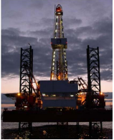
ASTRA jack up rig.
ASTRA jack up rig.

Baker Marine (BMC) 150 H cantilever jack-up operates in water at depths up to 150 feet and is capable of drilling to 15,000 feet. During 1011 two wells were drilled in Russian & Kazakh waters by this rig. At this time it is drilling in Russian waters.

LSP-1 platform on Yu. Korchagin field.

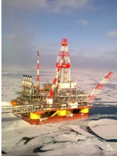
The Yuri Korchagin project started in 2004 and was concluded recently. The oil and gas field is located in the Russian sector of the North Caspian Sea. It will be the first of the North Caspian fields to be brought commercially on-stream, scheduled for December 2009. The field is 180 km from the City of Astrakhan and 240 km from Makhachkala at sea depth of 11-13 meters. 3P (proven, probable and possible) reserves are 570 million barrel of equivalent. Oil and gas condensate production will peak at 2.3 million tonnes oil and 1.2 bcm gas per year. First oil was produced in early 2010.
Noble Denton has successfully provided marine warranty services for the transportation and installation of offshore platform in the Yuri Korchagin oil field for Russian oil and gas company Lukoil. In conjunction with Crane Marine Contractor Limited (CMC) based in Astrakhan, Noble Denton was assigned to supply technical expertise for the tow of the ice-resistant fixed platform, LSP-1. During 1011 three horizontal development wells were drilled.
LSP-1 platform on Yu. Korchagin field.

Fixed platform.
The Molikpaq (Piltun-Astokhskoye-A platform) is the first offshore oil production platform in Russia. Commercial oil production from the platform was launched in 1999.
The structure was specifically built to operate in ice conditions. The steel spacer allowed for the water in the Sea of Okhotsk, and the completed substructure was filled with sand permanently anchoring it to the seabed.
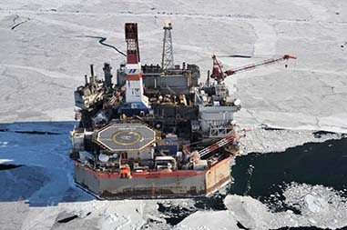
It is a converted drilling rig that was first used in Arctic waters offshore Canada. In 1998, the Molikpaq was towed from the Beaufort Sea in the Canadian Arctic across the Pacific Ocean to Korea where it was upgraded for the Sakhalin-2 Project. Then it was towed from Korea to Russia where a steel 'spacer', manufactured by Amur Shipyard was fitted to the bottom of the Molikpaq so that it could be used offshore Sakhalin Island. It was installed in the Astokh area of the Piltun-Astokhskoye field, 16 kilometres (9.9 mi) offshore, in September 1998.
Fixed platform.

Year-round oil production from the PA-A platform was launched in December 2008. Oil streams from the platform through the Transsakhalin pipeline system to the oil export terminal of the Prigorodnoye production complex.

The Molikpaq has production capacity of 90,000 barrels per day (14,000 m³/d) of oil and 1.7 million cubic meters of associated gas.

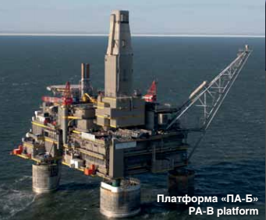
Piltun-Astokhskoye-B (PA-B) Platform.
Piltun-Astokhskoye-B (PA-B) Platform.

The Piltun-Astokhskoye-B (PA-B) platform was installed in July 2007 in the Piltun area of the Piltun-Astokhskoye field, 12 km offshore in the Sea of Okhotsk, at a depth of 32 m., designed for year-round production. The PA-B is a drilling, production and processing platform that will extract oil and associated gas from the Piltun reservoir.

Lunskoye-A (Lun-A) Platform.

The Lunskoye-A (Lun-A) platform was installed in June 2006 in the Lunskoye gas field, 15 km offshore in the Sea of Okhotsk at a depth of 48 m. It is designed for year-round production and produces the majority of gas for the LNG plant. The platform is equipped with minimum processing facilities. Gas treatment is carried out at the onshore processing facility (OPF) before the gas is transported to the LNG plant.
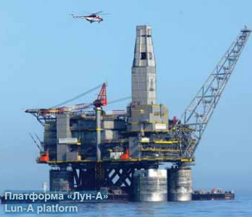
Jack up rigs and fixed platforms are the most popular in Russia, because their use is very practical in our climate and very favorable from the economic point of view. Infrastructure of offshore oil and gas rigs in Russia is developed very rapidly, because specialists are finding more and more new fields.

Lunskoye-A (Lun-A) Platform.

References:
- Russell Mclendon. Types of offshore oil rigs. // Mother Nature Network - May 19, 2010 [Electronic resource]. - Access mode. – URL: http://www.mnn.com/earth-matters/energy/stories/types-of-offshore-oil-rigs
- Mel Baker. 4 Types of Offshore Rigs Used In Modern Oil Drilling.// Top business design – NOV 10, 2014 [Electronic resource]. - Access mode. – URL:http://topbusinessdesign.com/2014/11/10/4-types-of-offshore-rigs-used-in-modern-oil-drilling/
- Wikipedia. Offshore Drilling. // Wikipedia - February 26, 2016 [Electronic resource]. - Access mode. – URL: https://en.wikipedia.org/wiki/Offshore_drilling
- Turkmenistan International Oil & Gas Conference. Investing in Jack-up Drilling Capacity for the Caspian Offshore Market. 15-17 November 2011. –4 page.
- S.D. Trefilova. A Translator’s Guide to Sakhalin-2. The brochure – 2009 – 19-37 pages.

